SCOAP3 project: an update

After a first three years cycle (2014-2016), the SCOAP3 project started a second cycle (2017-2019) with no major changes. The Swiss academic libraries concerned by publications in high-energy physics agreed upon the split of the financial commitment for Switzerland (column Share 2017-2019 in the following table) using the number of publications each institution is producing, or co-producing.
Institution | Share 2017-19 | Contribution
EPFL | 12.64% | 13'625.92 €
ETHZ | 19.29% | 20'794.62 €
Lib4RI | 4.63% | 4'991.14 €
UNIBA | 4.32% | 4'656.96 €
UNIBE | 23.70% | 25'548.60 €
UNIFR | 0.12% | 129.36 €
UNIGE | 10.79% | 11'631.62 €
UZH | 24.51% | 26'421.78 €
 | 100.00% | 107'800.00 €

It is important to underline how SCOAP3 succeeded in containing the publication costs. The overall increase over six years is only 2%. The bellow graph shows a comparison of the SCOAP3 costs with what would be a linear 2%-4% annual increase quite usual with traditional publishing models. The APC paid are in average of 1’032.- euros (17’500 sponsored articles).

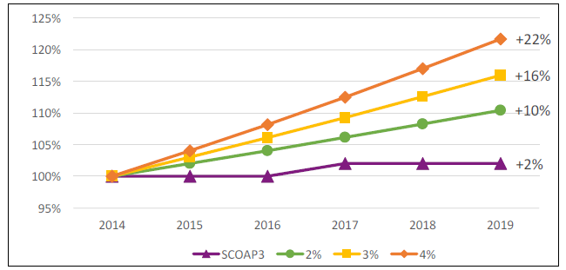

Inclusion of American Physical Society (APS)
APS retracted from the project shortly before the official launch of SCOAP3 in 2013. Nevertheless, they requested to be included for the second cycle. Successful negotiations took place and this publisher with three important journals joins the project for the two remaining years of the actual cycle (2018-2019).
With the inclusion of APS, SCOAP3 will cover 87% of all HEP articles published worldwide.
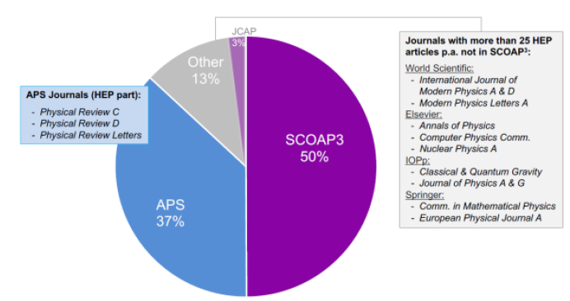

The calculation of the invoices for APS (see table below) is treated separately from the rest of SCOAP3 until the next cycle, but the same mechanism is applied. The 61’600$ due by Switzerland (3rd column) is split according to the number of articles published by APS and produced by each institution (2nd col.) The fourth column shows the discount granted by APS to the libraries for their subscriptions.
Lib4RI (for PSI) and ZHAW generously decided to give back to the community their savings on the subscription, so the amounts that will be invoiced early 2018 is presented in the last column.
APS 2018-2019
 | Share |  |  |  | APS |  |  |  |  |  | Voluntary
Institution | APS art. | First split |  | Discount |  | Delta |  |  |  | contribution |  | Invoicing
EPFL | 24.21% | 14'916.02 $ |  | 6'931.38 $ |  | 7'984.64 $ |  | 25.8% |  |  |  | 13'844.25 $
ETHZ | 16.78% | 10'337.79 $ |  | 6'931.38 $ |  | 3'406.41 $ |  | 11.0% |  |  |  | 9'880.55 $
PSI | 3.70% | 2'277.64 $ |  | 6'175.88 $ |  | -3'898.24 $ |  |  |  | 3'898.24 $ |  | 6'175.88 $
UNIBA | 1.54% | 951.41 $ |  | 5'813.13 $ |  | -4'861.72 $ |  |  |  |  |  | 951.41 $
UNIBE | 24.28% | 14'955.20 $ |  | 2'798.46 $ |  | 12'156.74 $ |  | 39.3% |  |  |  | 13'323.40 $
UNIFR | 0.60% | 370.06 $ |  | 4'449.65 $ |  | -4'079.59 $ |  |  |  |  |  | 370.06 $
UNIGE | 16.28% | 10'030.83 $ |  | 5'978.60 $ |  | 4'052.23 $ |  | 13.1% |  |  |  | 9'486.90 $
UNIL | 0.00% | 0.00 $ |  | 0.00 $ |  |  |  |  |  |  |  | 0.00 $
UZH | 12.60% | 7'761.05 $ |  | 4'449.65 $ |  | 3'311.40 $ |  | 10.7% |  |  |  | 7'316.56 $
ZHAW | 0.00% | 0.00 $ |  | 251.00 $ |  | -251.00 $ |  |  |  | 251.00 $ |  | 251.00 $
ZHB | 0.00% | 0.00 $ |  | 663.10 $ |  | -663.10 $ |  |  |  |  |  | 0.00 $
Total |  | 61'600.00 $ |  | 44'442.23 $ |  |  |  | 100.0% |  | 4'149.24 $ |  | 61'600.01 $

