SCOAP³ in Switzerland: A proposal for a revised allocation model for years 2017-2019
Updated April 19th 2016 with final figures

Aim
To determine the cost distribution among the Swiss partners for the second 3-year cycle of SCOAP3, the Geneva University Library revised the current allocation model with data from the SCOAP3 repository (http://repo.scoap3.org) and the latest achievements of the negotiations with publishers. This document explains the methodology and presents the resulting allocation model and projected costs.

Acknowledgement
The report is based on, and largely inspired by, a SCOAP3 study. It also received very useful feedbacks from Jochen Bihn (Lib4RI) and colleagues from Geneva, Basel and Bern.

Background
SCOAP3 is an international consortium constituted by 47 countries and Intergovernmental Organisations (as of the present date) aiming to convert subscription based articles/journals in the field of High Energy Physics (HEP) into full Open Access (List of titles in Appendix 1).
The consortium enters the last year of its first 3-year cycle and must re-evaluate the fair share contributions of its members, taking into account the “… volume of articles published in the SCOAP3 framework over a specified two-year reference period”.
For the period 2014-2016, the Swiss share is 1.43% of the fixed SCOAP3 budget, that is an annual contribution of 71’500 euros. With the most recent data (articles published in 2014 and 2015 and deposited into the repository), the CERN calculated the new contributions for each country. The relative weight of Switzerland at the international level increased from 1.3% to 2%, and therefore the Swiss contribution jumped from 1.43% to 2.2% of the SCOAP3 budget (see Appendix 2). With a global budget of 4.9 Mio €, the cost for Switzerland will raise to 107’800.- euros per year.

Methodology
For the calculation of the revised allocation key, any article published between January 1st, 2014 to December, 31st 2015, deposited into the SCOAP3 repository, from a journal that will be part of the 2017-2019 deal, and with at least one author affiliated with a Swiss institution, is retained. The metadata are gathered through the repository API, and processed according to the following sequence of rules.
- Each article is assigned to its authors proportionally, so that for n authors each of them receives a 1/n share of the article, regardless of the affiliations.
- Each author is assigned to his/her institutions proportionally, so that for k institutions to which an author is affiliated, each institution receives a 1/k share of the 1/n share of that author.
- The shares of each Swiss institution are summed up for all the articles.
- An allocation key is calculated by dividing the share of each institution by the total sum of the shares.

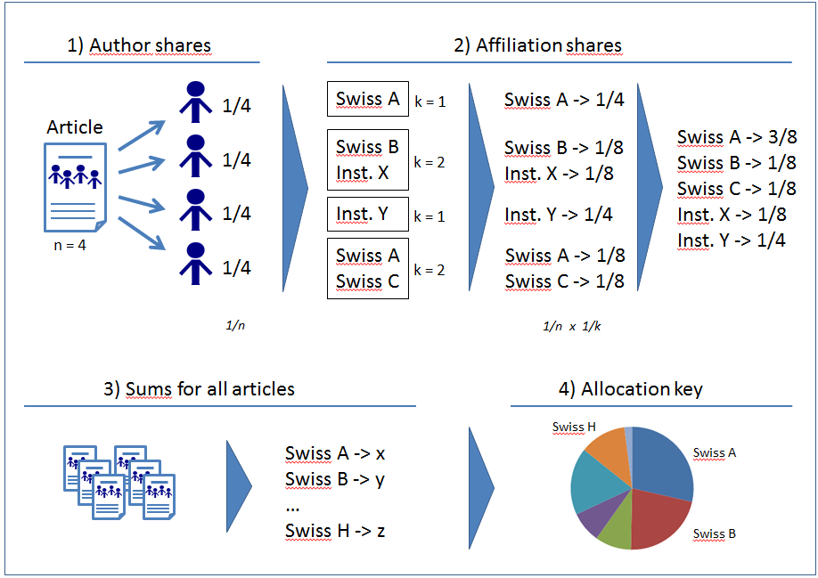
Figure 1: Schematic overview of the methodology used to calculate the Swiss institution shares

Data sample
Out of 8’752 articles published within the SCOAP3 framework between 2014 and 2015, 666 are attached to Switzerland (CERN excluded).
Journal Title | # articles
Acta Physica Polonica B | 1
Advances in High Energy Physics | 5
EPJC | 136
JCAP | 19
JHEP | 338
New J. Phys. | 2
Nuclear Physics B | 27
Physics Letters B | 134
PTEP | 4
Total | 666
After discarding 21 articles from the two IOPp journals that will step back from SCOAP3 in the next cycle (Journal of Cosmology and Astroparticle Physics (JCAP) and New Journal of Physics), and 2 articles from a private citizen not related to any Higher Education institution (Carlo A. Trugenberger, SwissScientific), the data sample is composed by 643 articles.

Affiliations mapping
There are 17’191 occurrences of Swiss affiliations corresponding to 248 unique entries than can be reduced to only 8 institutions as briefly illustrated here below:
ETH Zurich, 8093 Zurich, Switzerland ETHZ
ETH Zurich, CH-8093 Zurich, Switzerland ETHZ
ETH Zurich, Institute for Particle Physics, CH-8093 Zurich, Switzerland ETHZ
…

Revised allocation key
The computation of the sample data produces the relative share for each Swiss institution.
Institution | Share  2017 |  | Share  2015-2016
EPFL | 12.64% |  | 6.4%
ETHZ | 19.29% |  | 18.8%
Lib4RI | 4.63% |  | 13.9%
UNIBA | 4.32% |  | 1.9%
UNIBE | 23.70% |  | 19.8%
UNIFR | 0.12%
UNIGE | 10.79% |  | 17.2%
UZH | 24.51% |  | 22.0%
 | 100.00% |  | 100.0%
Table 1: Revised allocation key for 2017
The difference between the current allocation key and the proposed new one can be explained by two main reasons: 1) an increase/decrease of the publication output of the institution over the years; 2) a refinement of the methodology. Regarding that second point, we can say that articles with very large lists of co-authors (1000 or more) are less impacting an institution than articles with very few authors. This is caused by the relative weight of each author, 1/1000 or lesser in large collaboration articles, and something like from 1 to 1/10 for “regular” articles.

Financial commitment for Swiss institutions
The SCOAP3 budget for 2017-2019 is 4.9 Mio euros per year, and the Swiss contribution 107’800.- euros.
Based on the proposed allocation model, the projected costs for the Swiss institutions are presented in the following table.
Table 2: Allocation costs
Institution | Share 2015-2016 | Contribution 2015-2016 | Share 2017 | Share 2017 with flat contribution | Impact of the new allocation | Price increase+ | Increase of the Swiss fair share* | Contribution 2017
EPFL | 6.4% | 4'576.00 | 12.64% | 9'037.60 € | 4'461.60 € | 180.75 € | 4'407.57 € | 13'625.92 €
ETHZ | 18.8% | 13'442.00 | 19.29% | 13'792.35 € | 350.35 € | 275.85 € | 6'726.42 € | 20'794.62 €
Lib4RI | 13.9% | 9'938.50 | 4.63% | 3'310.45 € | -6'628.05 € | 66.21 € | 1'614.48 € | 4'991.14 €
UNIBA | 1.9% | 1'358.50 | 4.32% | 3'088.80 € | 1'730.30 € | 61.78 € | 1'506.38 € | 4'656.96 €
UNIBE | 19.8% | 14'157.00 | 23.70% | 16'945.50 € | 2'788.50 € | 338.91 € | 8'264.19 € | 25'548.60 €
UNIFR | 0.0% | 0.00 | 0.12% | 85.80 € | 85.80 € | 1.72 € | 41.84 € | 129.36 €
UNIGE | 17.2% | 12'298.00 | 10.79% | 7'714.85 € | -4'583.15 € | 154.30 € | 3'762.47 € | 11'631.62 €
UZH | 22.0% | 15'730.00 | 24.51% | 17'524.65 € | 1'794.65 € | 350.49 € | 8'546.64 € | 26'421.78 €
 | 100.0% | 71'500.00 | 100.00% | 71'500.00 € | 0.00 € | 1'430.00 € | 34'870.00 € | 107'800.00 €
+ The price increases by 2% from the first to the second cycle (0.39% annual increase over 6 years)
* The increase of the Swiss contribution is correlated with the higher proportion of articles published by Swiss authors

The overall increase of the SCOAP3 budget over six years (2014 -> 2019) is only 2% thanks to hard negotiations with publishers and fixed prices. This is a very low figure compared with the usual increase in subscription prices that occurs annually.
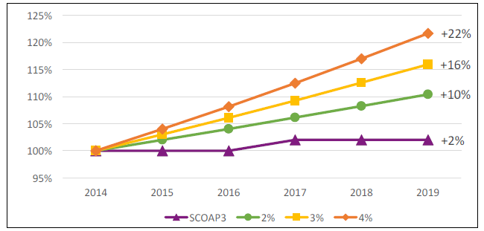
Figure 2: Comparison of the linear 2%-4% annual increase with the SCOAP3 increase

Future update of the allocation key
Now that the methodology is defined and the scripts written to perform the calculations, one should ask how often the allocation must be revised. Here are the three main options:
- Use the new allocation key for the three next years
- Revise the allocation key every year with the data of the two previous years
- Revise the allocation key every year, adding data from the previous year to the sample

Appendix 1

List of participating publishers (alphabetical order) and journals

Publisher | Journal | SCOAP3  Articles  (in 2011) | SCOAP3  Percentage of journal  (in 2011)
Elsevier | Physics Letters B | 1010 | 100%
Elsevier | Nuclear Physics B | 284 | 100%
Hindawi | Advances in High Energy Physics | 28 | 100%
Institute of Physics Publishing/Chinese Academy of Sciences | Chinese Physics C | 16 | 7.20%
Institute of Physics Publishing/Deutsche Physikalische Gesellschaft | New Journal of Physics | 20 | 2.70%
Institute of Physics Publishing/SISSA | Journal of Cosmology and Astroparticle Physics | 138 | 30.90%
Jagiellonian University | Acta Physica Polonica B | 32 | 22.10%
Oxford University Press/Physical Society of Japan | Progress of Theoretical and experimental Physics | 46 | 36.20%
Springer/Società Italiana di Fisica | European Physical Journal C | 326 | 100%
Springer/SISSA | Journal of High Energy Physics | 1652 | 100%

Appendix 2

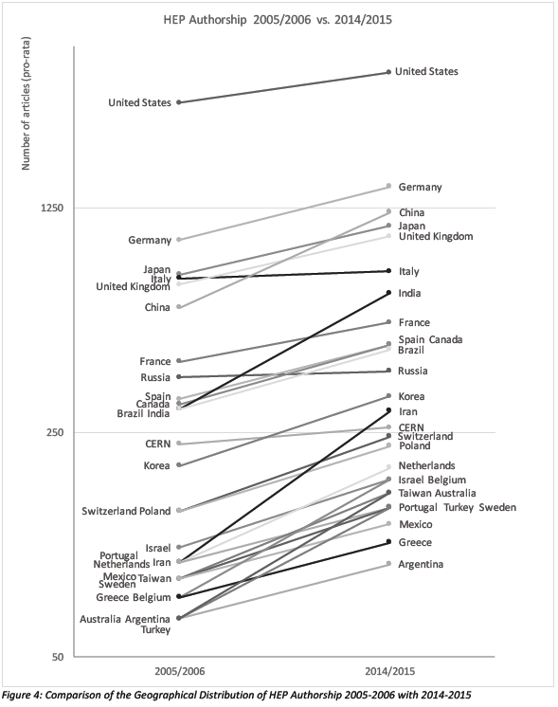
A. Kohls, E. Jaggi, W. Ziolek, Quantitative Analysis of the Geographical Distribution of High-Energy Physics Publications in 2014-2015 and calculation of the SCOAP3 Phase 2 “fair share” contributions, CERN, Geneva, February 2016. p. 13.

A. Kohls, E. Jaggi, W. Ziolek, Quantitative Analysis of the Geographical Distribution of High-Energy Physics Publications in 2014-2015 and calculation of the SCOAP3 Phase 2 “fair share” contributions, CERN, Geneva, February 2016. [to be released soon]
As stated in the Memorandum of Understanding that binds the partners together.
The contribution of each country corresponds to the publication output in HEP of that country plus an additional provision of 10% to cover countries that cannot be reasonably expected to contribute to SCOAP3.
The American Physical Society (APS) journals were finally not included in SCOAP3. If so, the Swiss share would be only 1.5%.

