SCOAP³ in Switzerland:
Cost allocation for the third phase (2020-2022)

Preamble
As we did for the two previous 3-year cycles of the SCOAP3 initiative, the Geneva University Library determined the cost distribution among the Swiss partners, following the methodology defined in 2016, and using publication data from the three last complete years (2016-2018).

Background
SCOAP3 is an international consortium constituted by 47 countries and Intergovernmental Organisations (as of the present date) aiming to convert subscription based articles/journals in the field of High Energy Physics (HEP) into full Open Access (list of journals and partners available on https://scoap3.org).
The consortium is starting in 2020 its third 3-year cycle and has signed new agreements with publishers, as always containing cost increase, but introducing a new competitive dimension into them. More information on these agreements to be announced by SCOAP3.
In this third phase, all amounts are in euros. CERN used data from the two last years to calculate the weight of Switzerland in the High Energy Physics publication field. This weight (1.6% of the total output with a Swiss affiliation), and therefore the Swiss commitment to the SCOAP3 budget of € 171’000.-, remain very stable.

Methodology for calculating the Swiss allocation
All articles published from January 1st 2016 to December 31st 2018 with at least one author affiliated within a Swiss institution are retrieved through the SCOAP3 repository API, and then processed in the following order:
- Each article is assigned to its authors proportionally, so that for n authors each of them receives a 1/n share of the article, regardless of the affiliations.
- Each author is assigned to his/her institutions proportionally, so that for k institutions to which an author is affiliated, each institution receives a 1/k share of the 1/n share of that author.
- The shares of each Swiss institution are summed up.
- An allocation key is calculated by dividing the share of each institution by the total sum of the shares.

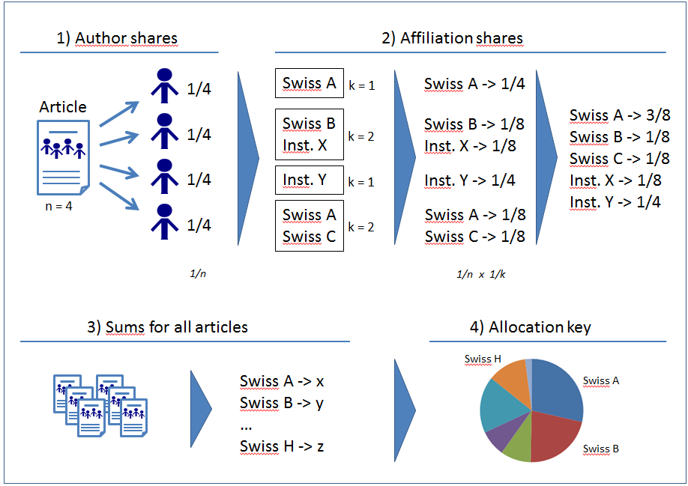
Figure 1: Schematic overview of the methodology used to calculate the Swiss institution shares

Data sample
Out of 15’944 articles published within the SCOAP3 framework between 2016 and 2018, 1324 present at least one author with a Swiss affiliation.
Journal Title | # articles | Publisher
Adv. High Energy Phys. | 1 | Hindawi
Chinese Physics C | 2 | IOP
European Physical Journal C | 278 | Springer
J. Cosm. and Astroparticle P. | 20 | IOP
J. High Energy Phys. | 588 | Springer
New Journal of Physics | 2 | IOP
Nuclear Physics B | 33 | Elsevier
Physical Review C | 3 | APS
Physical Review D | 117 | APS
Physical Review Letters | 60 | APS
Physics Letters B | 216 | Elsevier
Prog. of Theor. and Exp. Phys. | 4 | OUP

Affiliations mapping
In these 1324 articles, we find 1’725’563 affiliations, reduced to 658 unique Swiss occurrences, which can be mapped to 9 academic institutions.

Revised allocation key and financial commitment
The sum of the weight by author by institution is shown in the second column of the following table. Converted into a percentage (fourth column), we can calculate the amount due to the SCOAP3 Consortium by each Swiss institution. For information, the last column reminds the share calculated for the second phase (2017-2019).
Institution | Sum of ratio authors/institutions  2016-2018 | Share 2020-2022  % |  | Contribution 2020-2022 | Share 2017
EPFL | 32.78054988 | 12.49% | 12.50% | € 21'371.12 | 12.64%
ETHZ | 68.61973691 | 26.15% | 26.16% | € 44'736.31 | 19.29%
Lib4RI | 15.61775681 | 5.95% | 5.95% | € 10'181.92 | 4.63%
UNIBA | 8.576636464 | 3.27% | 3.27% | € 5'591.50 | 4.32%
UNIBE | 56.85310338 | 21.66% | 21.68% | € 37'065.11 | 23.70%
UNIGE | 25.64426065 | 9.77% | 9.78% | € 16'718.65 | 10.79%
UZH | 54.19994482 | 20.65% | 20.66% | € 35'335.39 | 24.51%
UNIFR | 0.01499373 | 0.01% |  | -
UNINE | 0.112637363 | 0.04% |  | -
Total | 262.41962 | 100.00% | 100.00% | € 171'000.00

Jupyter Notebook
All the processes (download of records via the API, search for the Swiss authors, pondering of affiliations, final summing) is executed by a single Python script created as a Jupyter Notebook that is available for check and reuse. As the data are also open, everybody can verify the correctness of our analysis and outputs.

Time frame for the next allocation
By the virtue of this script, we can now calculate new figures seamlessly every year if wanted. Is it preferable to do so, or to stick with a three years evaluation and commitment?

Conclusion
The overall increase of the SCOAP3 budget over six years (2014 -> 2019) was only 2% thanks to hard negotiations with publishers and fixed prices. For the near future, the increase will even by lower, with a tiny 0.5% over the next three years for Switzerland (not 0.5% by year!). This only number shows the great success of SCOAP3.

Open source software based on IPython: https://jupyter.org/
https://www.unige.ch/biblio/index.php?cID=1859

