Supplementary Material

for “Introducing the Geneva Emotion Recognition Test: An example of Rasch-based test development.”

Table S1a
Number of items completed by the 454 participants.
number of items completed | participants N | cumulated percent participants |  | number of items completed | participants N | cumulated percent participants
2 | 10 | 2 |  | 49 | 1 | 26
3 | 1 | 2 |  | 50 | 1 | 27
4 | 4 | 3 |  | 51 | 1 | 27
5 | 2 | 4 |  | 53 | 2 | 27
6 | 2 | 4 |  | 54 | 1 | 28
8 | 3 | 5 |  | 55 | 1 | 28
9 | 4 | 6 |  | 57 | 1 | 28
11 | 2 | 6 |  | 58 | 4 | 29
12 | 1 | 6 |  | 59 | 2 | 29
13 | 1 | 6 |  | 62 | 2 | 30
14 | 5 | 8 |  | 64 | 1 | 30
16 | 5 | 9 |  | 65 | 1 | 30
17 | 5 | 10 |  | 68 | 1 | 30
18 | 2 | 10 |  | 69 | 1 | 31
19 | 4 | 11 |  | 70 | 2 | 31
20 | 3 | 12 |  | 75 | 1 | 31
21 | 3 | 12 |  | 76 | 1 | 32
22 | 6 | 14 |  | 77 | 2 | 32
23 | 3 | 14 |  | 81 | 1 | 32
24 | 5 | 15 |  | 82 | 1 | 32
25 | 3 | 16 |  | 83 | 2 | 33
26 | 2 | 17 |  | 86 | 3 | 33
27 | 3 | 17 |  | 87 | 1 | 34
28 | 4 | 18 |  | 90 | 2 | 34
29 | 6 | 19 |  | 92 | 1 | 34
30 | 1 | 20 |  | 94 | 1 | 35
32 | 2 | 20 |  | 97 | 1 | 35
33 | 1 | 20 |  | 100 | 1 | 35
34 | 1 | 21 |  | 102 | 3 | 36
36 | 3 | 21 |  | 103 | 1 | 36
37 | 1 | 21 |  | 104 | 3 | 37
38 | 3 | 22 |  | 105 | 4 | 37
39 | 2 | 22 |  | 106 | 9 | 39
40 | 1 | 23 |  | 107 | 19 | 44
41 | 1 | 23 |  | 108 | 255 | 100
42 | 4 | 24
44 | 2 | 24
45 | 1 | 24
46 | 6 | 26
48 | 2 | 26
Note. Total N=454. Total number of items in the study was 108. The Table shows that 56% of all participants (N=255) that had started the study completed all 108 items. 100 items were completed by 295 participants, and 80% of the items (i.e., 86 items) were completed by 304 participants. Most participants that did not finish the study dropped out before completing 80% of the items.

Table S1b

Demographic characteristics of the analyzed and dropout sample.

 | analyzed sample (N=295)  % | dropout sample (N=159)  %
gender: male | 28 | 28
educational level (highest degree obtained)
no degree | 2 | 2
obligatory school | 3 | 5
junior high school | 17 | 15
senior high school | 34 | 45
bachelor/ master | 39 | 31
PhD | 5 | 2
occupational status
high school student | 5 | 8
college/ university student | 24 | 33
employed | 35 | 32
unemployed | 6 | 2
official/ functionary | 4 | 4
housewife/ househusband | 2 | 3
self-employed/ freelancer | 11 | 8
retired | 8 | 6
other | 5 | 4
age mean | 37.1 | 32.2
Note. Gender, educational level, and occupational status did not differ significantly between the analyzed and the dropout sample. The age difference was significant.

Table S2

Model fit indices for the final 14 CFAs and item fit indices for the 14 Rasch analyses conducted for each emotion subset.

 | CFA results |  |  |  |  |  | Rasch model results
emotion | N of excluded items | N of retained items | CFI | RMSEA | RMSR |  | item number | Infit | Outfit
amusement | 1 | 7 | 1.000 | .000 | .076 |  | amu01 | 0.96 | 0.95
 |  |  |  |  |  |  | amu02 | 1.03 | 0.98
 |  |  |  |  |  |  | amu03 | 0.92 | 0.92
 |  |  |  |  |  |  | amu04 | 1.06 | 1.10
 |  |  |  |  |  |  | amu05 | 0.90 | 0.66
 |  |  |  |  |  |  | amu06 | 0.98 | 0.94
 |  |  |  |  |  |  | amu07** | 0.89 | 0.87
anger | 1* | 7 | 1.000 | .000 | .048 |  | ang07 | 1.07 | 1.15
 |  |  |  |  |  |  | ang08 | 0.94 | 0.95
 |  |  |  |  |  |  | ang09 | 0.95 | 0.90
 |  |  |  |  |  |  | ang10 | 0.91 | 0.92
 |  |  |  |  |  |  | ang11 | 0.83 | 0.77
 |  |  |  |  |  |  | ang12 | 1.02 | 1.06
 |  |  |  |  |  |  | ang13** | 0.92 | 0.86
disgust | 0 | 7 | .950 | .045 | .084 |  | dis13 | 0.83 | 0.76
 |  |  |  |  |  |  | dis14 | 0.95 | 0.93
 |  |  |  |  |  |  | dis15 | 0.78 | 0.59
 |  |  |  |  |  |  | dis16 | 0.83 | 0.71
 |  |  |  |  |  |  | dis17 | 0.86 | 1.04
 |  |  |  |  |  |  | dis18 | 0.99 | 1.03
 |  |  |  |  |  |  | dis19** | 0.80 | 0.73
despair | 2 | 5 | .976 | .020 | .067 |  | des19 | 0.94 | 0.91
 |  |  |  |  |  |  | des20 | 1.06 | 1.06
 |  |  |  |  |  |  | des21 | 0.92 | 0.85
 |  |  |  |  |  |  | des22 | 0.92 | 0.89
 |  |  |  |  |  |  | des23 | 0.94 | 0.93
pride | 0 | 8 | 1.000 | .000 | .068 |  | pri24 | 1.07 | 1.10
 |  |  |  |  |  |  | pri25 | 1.03 | 1.05
 |  |  |  |  |  |  | pri26 | 0.95 | 0.92
 |  |  |  |  |  |  | pri27 | 0.94 | 0.88
 |  |  |  |  |  |  | pri28 | 0.92 | 0.86
 |  |  |  |  |  |  | pri29 | 0.99 | 1.00
 |  |  |  |  |  |  | pri30** | 0.95 | 0.94
 |  |  |  |  |  |  | pri31** | 0.94 | 1.08
anxiety | 0 | 8 | 1.000 | .000 | .068 |  | anx30 | 0.96 | 0.93
 |  |  |  |  |  |  | anx31 | 0.98 | 0.97
 |  |  |  |  |  |  | anx32 | 1.09 | 1.17
 |  |  |  |  |  |  | anx33 | 1.00 | 1.03
 |  |  |  |  |  |  | anx34 | 0.86 | 0.79
 |  |  |  |  |  |  | anx35 | 0.98 | 0.96
 |  |  |  |  |  |  | anx36** | 0.98 | 0.96
 |  |  |  |  |  |  | anx37** | 0.90 | 0.89

Table S2 (continued)

 | CFA results |  |  |  |  |  | Rasch model results
emotion | N of excluded items | N of retained items | CFI | RMSEA | RMSR |  | item number | Infit | Outfit
interest | 1 | 6 | .996 | .007 | .070 |  | int36 | 1.02 | 1.02
 |  |  |  |  |  |  | int37 | 1.02 | 1.00
 |  |  |  |  |  |  | int38 | 0.97 | 0.97
 |  |  |  |  |  |  | int39 | 1.01 | 0.93
 |  |  |  |  |  |  | int40 | 0.80 | 0.71
 |  |  |  |  |  |  | int41 | 0.82 | 0.75
irritation | 0 | 7 | .947 | .062 | .084 |  | irr42 | 1.00 | 0.92
 |  |  |  |  |  |  | irr43 | 1.07 | 1.07
 |  |  |  |  |  |  | irr44 | 0.74 | 0.72
 |  |  |  |  |  |  | irr45 | 0.95 | 0.93
 |  |  |  |  |  |  | irr46 | 1.16 | 1.18
 |  |  |  |  |  |  | irr47 | 0.92 | 0.92
 |  |  |  |  |  |  | irr48** | 1.11 | 1.19
joy | 1 | 8 | 1.000 | .000 | .070 |  | joy48 | 0.86 | 0.78
 |  |  |  |  |  |  | joy49 | 1.07 | 1.07
 |  |  |  |  |  |  | joy50 | 1.05 | 1.08
 |  |  |  |  |  |  | joy51 | 0.87 | 0.81
 |  |  |  |  |  |  | joy52 | 1.01 | 1.06
 |  |  |  |  |  |  | joy53 | 0.90 | 0.86
 |  |  |  |  |  |  | joy54** | 0.96 | 0.99
 |  |  |  |  |  |  | joy55** | 0.99 | 0.97
fear | 0 | 8 | .992 | .016 | .062 |  | fea54 | 0.95 | 0.91
 |  |  |  |  |  |  | fea55 | 0.95 | 0.95
 |  |  |  |  |  |  | fea56 | 1.09 | 1.13
 |  |  |  |  |  |  | fea57 | 0.96 | 0.96
 |  |  |  |  |  |  | fea58 | 0.90 | 0.81
 |  |  |  |  |  |  | fea59 | 0.97 | 0.95
 |  |  |  |  |  |  | fea60** | 1.01 | 0.97
 |  |  |  |  |  |  | fea61** | 0.97 | 0.94
pleasure | 0 | 8 | 1.000 | .000 | .077 |  | ple60 | 0.97 | 0.96
 |  |  |  |  |  |  | ple61 | 0.93 | 0.92
 |  |  |  |  |  |  | ple62 | 1.03 | 1.30
 |  |  |  |  |  |  | ple63 | 0.93 | 0.82
 |  |  |  |  |  |  | ple64 | 0.93 | 0.91
 |  |  |  |  |  |  | ple65 | 0.92 | 0.89
 |  |  |  |  |  |  | ple66** | 1.07 | 1.07
 |  |  |  |  |  |  | ple67** | 0.65 | 0.18
relief | 2 | 7 | .926 | .044 | .101 |  | rel66 | 0.91 | 0.88
 |  |  |  |  |  |  | rel67 | 1.14 | 1.15
 |  |  |  |  |  |  | rel68 | 0.90 | 0.88
 |  |  |  |  |  |  | rel69 | 1.16 | 1.22
 |  |  |  |  |  |  | rel70 | 0.89 | 0.79
 |  |  |  |  |  |  | rel71 | 0.94 | 0.94
 |  |  |  |  |  |  | rel72** | 0.90 | 0.78

Table S2 (continued)

 | CFA results |  |  |  |  |  | Rasch model results
emotion | N of excluded items | N of retained items | CFI | RMSEA | RMSR |  | item number | Infit | Outfit
surprise | 0 | 6 | .949 | .047 | .078 |  | sur72 | 0.91 | 0.87
 |  |  |  |  |  |  | sur73 | 0.92 | 0.92
 |  |  |  |  |  |  | sur74 | 0.75 | 0.64
 |  |  |  |  |  |  | sur75 | 0.91 | 0.87
 |  |  |  |  |  |  | sur76 | 0.84 | 0.77
 |  |  |  |  |  |  | sur77 | 1.00 | 1.12
sadness | 1 | 7 | .998 | .008 | .066 |  | sad78 | 0.85 | 0.81
 |  |  |  |  |  |  | sad79 | 0.88 | 0.81
 |  |  |  |  |  |  | sad80 | 1.08 | 1.10
 |  |  |  |  |  |  | sad81 | 0.91 | 0.90
 |  |  |  |  |  |  | sad82 | 0.94 | 0.90
 |  |  |  |  |  |  | sad83 | 0.96 | 0.84
 |  |  |  |  |  |  | sad84** | 0.98 | 0.92

Note. The fit indices of the CFAs (Confirmatory Factor Analyses) are based on all items for a given emotion from the original set of 108 after poorly fitting items had been removed (see columns 2 and 3). The 14 Rasch model analyses are based on the item subsets modeled with these CFAs. From these subsets (a total of 99 items), six items per emotion were chosen in a next step according to item difficulty and gender composition, leading to the final total set of 83 items that are reported in Table S3 below. The items that were eliminated in this final selection step are marked with **. CFI= Comparative Fit Index, RMSEA= Root Mean Square Error of Approximation, RMSR= Root Mean Square Residual. *= the item was excluded because it was solved correctly by 98% of the sample.

Table S3
Actor number, recognition rates, difficulty parameters and standard errors, Infit/Outfit indices, and perpendicular distances for assessing age and gender DIF for the final 83 GERT items.
Item | Actor number | M | δ | SE | Infit | Outfit | PD for age | PD for gender
amu01 | 01 | 0.82 | -1.56 | 0.15 | 1.01 | 1.01 | -0.14 | -0.27
amu02 | 02 | 0.64 | -0.61 | 0.12 | 0.98 | 0.95 | 0.33 | 1.54
amu03 | 03 | 0.83 | -1.66 | 0.16 | 0.99 | 0.94 | 0.49 | 0.13
amu04 | 04 | 0.89 | -2.15 | 0.19 | 1.01 | 1.08 | -0.48 | -1.13
amu05 | 06 | 0.94 | -2.83 | 0.25 | 0.98 | 0.88 | 0.27 | 0.82
amu06 | 10 | 0.78 | -1.30 | 0.14 | 1.01 | 1.05 | 0.34 | -0.31
ang07 | 03 | 0.48 | 0.10 | 0.12 | 1.00 | 0.99 | 0.73 | -0.70
ang08 | 04 | 0.62 | -0.50 | 0.12 | 0.93 | 0.91 | 0.93 | 0.36
ang09 | 06 | 0.63 | -0.55 | 0.12 | 0.94 | 0.93 | 1.29 | 0.29
ang10 | 07 | 0.31 | 0.84 | 0.13 | 1.00 | 0.99 | -0.31 | -0.95
ang11 | 08 | 0.71 | -0.96 | 0.13 | 0.93 | 0.89 | 0.83 | 0.20
ang12 | 08 | 0.57 | -0.31 | 0.12 | 0.97 | 0.96 | 0.47 | 0.30
dis13 | 02 | 0.48 | 0.07 | 0.12 | 0.98 | 0.97 | -0.67 | -0.28
dis14 | 04 | 0.49 | 0.04 | 0.12 | 0.95 | 0.94 | 0.45 | -0.43
dis15 | 04 | 0.17 | 1.67 | 0.16 | 0.90 | 0.75 | 0.61 | 0.10
dis16 | 05 | 0.89 | -2.15 | 0.19 | 0.97 | 0.88 | 0.77 | -0.04
dis17 | 09 | 0.74 | -1.07 | 0.14 | 0.93 | 0.89 | -0.13 | 0.85
dis18 | 09 | 0.26 | 1.11 | 0.14 | 0.99 | 1.00 | -0.02 | -0.79
des19 | 02 | 0.62 | -0.52 | 0.12 | 0.97 | 0.98 | -0.45 | 0.58
des20 | 03 | 0.59 | -0.38 | 0.12 | 1.03 | 1.04 | -0.79 | 0.01
des21 | 05 | 0.88 | -2.08 | 0.18 | 0.99 | 0.96 | -0.19 | 0.31
des22 | 09 | 0.82 | -1.55 | 0.15 | 1.00 | 0.99 | -0.69 | 1.36
des23 | 09 | 0.69 | -0.83 | 0.13 | 1.00 | 1.00 | -0.19 | 1.13
pri24 | 03 | 0.70 | -0.91 | 0.13 | 1.07 | 1.12 | 0.05 | 0.44
pri25 | 05 | 0.62 | -0.50 | 0.12 | 1.02 | 1.01 | 0.57 | 0.10
pri26 | 06 | 0.46 | 0.18 | 0.12 | 1.01 | 1.02 | 0.72 | 0.36
pri27 | 08 | 0.62 | -0.52 | 0.12 | 0.95 | 0.95 | 0.77 | 0.24
pri28 | 09 | 0.81 | -1.49 | 0.15 | 0.94 | 0.88 | 1.02 | -0.08
pri29 | 09 | 0.60 | -0.44 | 0.12 | 1.04 | 1.06 | -1.08 | 0.62
anx30 | 02 | 0.77 | -1.24 | 0.14 | 1.04 | 1.08 | 0.36 | -0.81
anx31 | 04 | 0.63 | -0.55 | 0.12 | 1.00 | 0.99 | 0.22 | -0.07
anx32 | 05 | 0.61 | -0.45 | 0.12 | 1.06 | 1.08 | -0.26 | -0.14
anx33 | 06 | 0.79 | -1.38 | 0.15 | 0.99 | 0.97 | 0.10 | 0.01
anx34 | 07 | 0.87 | -1.95 | 0.17 | 0.99 | 0.93 | 0.06 | 0.47
anx35 | 08 | 0.62 | -0.51 | 0.12 | 0.96 | 0.96 | 0.73 | 0.14
int36 | 01 | 0.60 | -0.43 | 0.12 | 1.05 | 1.05 | -0.29 | -0.36
int37 | 02 | 0.52 | -0.10 | 0.12 | 1.08 | 1.09 | -0.83 | 0.26
int38 | 04 | 0.41 | 0.37 | 0.12 | 1.11 | 1.13 | -0.05 | -0.77
int39 | 05 | 0.80 | -1.42 | 0.15 | 1.08 | 1.21 | -1.21 | 0.73
int40 | 09 | 0.89 | -2.23 | 0.19 | 1.00 | 1.06 | 0.83 | -1.40
int41 | 10 | 0.77 | -1.26 | 0.14 | 1.00 | 1.05 | 0.14 | -1.10

Table S3 (continued)
Item | Actor number | M | δ | SE | Infit | Outfit | PD for age | PD for gender
irr42 | 04 | 0.79 | -1.37 | 0.15 | 0.93 | 0.91 | 0.64 | -0.19
irr43 | 05 | 0.66 | -0.72 | 0.13 | 0.92 | 0.90 | 0.29 | 0.10
irr44 | 06 | 0.73 | -1.02 | 0.13 | 0.86 | 0.81 | 1.87* | 0.44
irr45 | 07 | 0.62 | -0.51 | 0.12 | 0.92 | 0.91 | 1.21 | -0.28
irr46 | 08 | 0.68 | -0.80 | 0.13 | 1.03 | 1.03 | -0.56 | -0.66
irr47 | 09 | 0.71 | -0.94 | 0.13 | 0.93 | 0.91 | 1.15 | -0.28
joy48 | 01 | 0.75 | -1.15 | 0.14 | 0.92 | 0.90 | 0.27 | 0.54
joy49 | 02 | 0.71 | -0.95 | 0.13 | 1.02 | 1.03 | -0.02 | 0.11
joy50 | 03 | 0.74 | -1.12 | 0.14 | 1.04 | 1.08 | -0.06 | 0.28
joy51 | 06 | 0.77 | -1.28 | 0.14 | 0.95 | 0.90 | 0.06 | -1.07
joy52 | 07 | 0.69 | -0.82 | 0.13 | 1.01 | 0.99 | 0.10 | -0.29
joy53 | 08 | 0.85 | -1.78 | 0.16 | 1.02 | 1.02 | 0.02 | 0.45
fea54 | 03 | 0.68 | -0.80 | 0.13 | 1.00 | 0.98 | -0.86 | 1.17
fea55 | 05 | 0.41 | 0.40 | 0.12 | 0.92 | 0.91 | -0.15 | 0.25
fea56 | 06 | 0.47 | 0.12 | 0.12 | 1.08 | 1.09 | 0.09 | -0.62
fea57 | 07 | 0.42 | 0.32 | 0.12 | 0.96 | 0.96 | 0.91 | 0.68
fea58 | 08 | 0.32 | 0.81 | 0.13 | 0.99 | 1.01 | 0.22 | 0.47
fea59 | 10 | 0.49 | 0.03 | 0.12 | 0.97 | 0.96 | 0.72 | -0.06
ple60 | 01 | 0.79 | -1.36 | 0.15 | 1.01 | 0.99 | 0.50 | -0.34
ple61 | 05 | 0.73 | -1.02 | 0.13 | 1.03 | 1.04 | -1.14 | 0.04
ple62 | 06 | 0.46 | 0.18 | 0.12 | 1.09 | 1.10 | -1.03 | -0.54
ple63 | 07 | 0.87 | -1.95 | 0.17 | 0.93 | 0.80 | 1.17 | -0.23
ple64 | 08 | 0.83 | -1.63 | 0.16 | 0.96 | 0.94 | 0.16 | 0.24
ple65 | 10 | 0.65 | -0.63 | 0.13 | 1.05 | 1.06 | -1.06 | -0.19
rel66 | 01 | 0.90 | -2.30 | 0.20 | 0.98 | 0.88 | -0.27 | 0.01
rel67 | 03 | 0.81 | -1.49 | 0.15 | 1.02 | 1.04 | -0.96 | 0.43
rel68 | 04 | 0.86 | -1.86 | 0.17 | 1.00 | 1.02 | -1.27 | 0.97
rel69 | 06 | 0.86 | -1.87 | 0.17 | 0.99 | 0.99 | -0.65 | 0.64
rel70 | 07 | 0.93 | -2.66 | 0.23 | 0.98 | 0.90 | -1.39 | -0.22
rel71 | 09 | 0.81 | -1.53 | 0.15 | 1.00 | 0.99 | -0.58 | 0.56
sur72 | 01 | 0.33 | 0.74 | 0.13 | 1.08 | 1.14 | -0.66 | -0.06
sur73 | 01 | 0.31 | 0.82 | 0.13 | 1.10 | 1.13 | -0.64 | -0.68
sur74 | 03 | 0.06 | 2.82 | 0.25 | 0.97 | 0.95 | -0.88 | -2.15*
sur75 | 06 | 0.48 | 0.10 | 0.12 | 1.00 | 0.99 | -0.52 | -0.94
sur76 | 06 | 0.60 | -0.42 | 0.12 | 1.06 | 1.06 | 0.21 | -0.03
sur77 | 07 | 0.74 | -1.10 | 0.14 | 1.01 | 0.99 | -0.48 | -0.48
sad78 | 02 | 0.86 | -1.92 | 0.17 | 0.98 | 0.96 | 0.54 | 0.36
sad79 | 02 | 0.87 | -1.96 | 0.17 | 1.02 | 1.09 | 0.26 | -0.94
sad80 | 04 | 0.62 | -0.50 | 0.12 | 1.02 | 1.04 | -0.36 | 0.34
sad81 | 05 | 0.81 | -1.54 | 0.15 | 1.03 | 1.03 | -0.88 | -0.69
sad82 | 05 | 0.83 | -1.68 | 0.16 | 1.00 | 1.01 | -0.60 | -0.79
sad83 | 10 | 0.83 | -1.66 | 0.16 | 0.99 | 1.05 | -0.69 | -0.24
Note: M=mean recognition rates, δ= difficulty parameters, SE=standard errors, PD=perpendicular distances , amu=amusement, ang=anger, dis=disgust, des=despair, pri=pride, anx=anxiety, int=interest, irr=irritation, fea=fear, ple=pleasure, rel=relief, sur=surprise, sad=sadness. Actors 01, 03, 04, 05, 08 are male, actors 02, 06, 07, 09, 10 are female. The difficulty parameters have been estimated with the mean of the ability distribution fixed to zero. Perpendicular distances were obtained using the modified Angoff’s delta plot approach (Magis & Facon, 2012). For age, the empirically derived PD threshold for DIF detection was │1.78│ and for gender, the threshold was │1.63│ (alpha=.01). Positive PDs indicate that an item is relatively easier for older subjects (for age) or for men (for gender), respectively. *= item flagged as DIF.

Table S4
Allocation of raw GERT test scores (sum of correct responses) to ability estimates and standard errors.
Raw GERT score |  | SE |  | Raw GERT score |  | SE
1 | -6.83 | 1.83 |  | 43 | -0.82 | 0.24
2 | -5.62 | 1.01 |  | 44 | -0.76 | 0.24
3 | -4.90 | 0.72 |  | 45 | -0.71 | 0.24
4 | -4.47 | 0.60 |  | 46 | -0.65 | 0.24
5 | -4.16 | 0.52 |  | 47 | -0.59 | 0.24
6 | -3.92 | 0.47 |  | 48 | -0.53 | 0.24
7 | -3.71 | 0.43 |  | 49 | -0.47 | 0.24
8 | -3.54 | 0.41 |  | 50 | -0.41 | 0.24
9 | -3.38 | 0.38 |  | 51 | -0.35 | 0.25
10 | -3.24 | 0.37 |  | 52 | -0.29 | 0.25
11 | -3.11 | 0.35 |  | 53 | -0.23 | 0.25
12 | -3.00 | 0.34 |  | 54 | -0.17 | 0.25
13 | -2.89 | 0.33 |  | 55 | -0.11 | 0.25
14 | -2.78 | 0.32 |  | 56 | -0.04 | 0.25
15 | -2.69 | 0.31 |  | 57 | 0.02 | 0.26
16 | -2.59 | 0.30 |  | 58 | 0.09 | 0.26
17 | -2.51 | 0.29 |  | 59 | 0.16 | 0.26
18 | -2.42 | 0.29 |  | 60 | 0.23 | 0.26
19 | -2.34 | 0.28 |  | 61 | 0.30 | 0.27
20 | -2.26 | 0.28 |  | 62 | 0.37 | 0.27
21 | -2.19 | 0.27 |  | 63 | 0.44 | 0.28
22 | -2.11 | 0.27 |  | 64 | 0.52 | 0.28
23 | -2.04 | 0.27 |  | 65 | 0.60 | 0.28
24 | -1.97 | 0.26 |  | 66 | 0.68 | 0.29
25 | -1.90 | 0.26 |  | 67 | 0.77 | 0.30
26 | -1.84 | 0.26 |  | 68 | 0.86 | 0.30
27 | -1.77 | 0.25 |  | 69 | 0.95 | 0.31
28 | -1.71 | 0.25 |  | 70 | 1.05 | 0.32
29 | -1.65 | 0.25 |  | 71 | 1.15 | 0.33
30 | -1.58 | 0.25 |  | 72 | 1.26 | 0.34
31 | -1.52 | 0.25 |  | 73 | 1.38 | 0.35
32 | -1.46 | 0.25 |  | 74 | 1.51 | 0.36
33 | -1.40 | 0.24 |  | 75 | 1.65 | 0.38
34 | -1.34 | 0.24 |  | 76 | 1.80 | 0.40
35 | -1.28 | 0.24 |  | 77 | 1.97 | 0.42
36 | -1.22 | 0.24 |  | 78 | 2.16 | 0.45
37 | -1.17 | 0.24 |  | 79 | 2.38 | 0.49
38 | -1.11 | 0.24 |  | 80 | 2.64 | 0.54
39 | -1.05 | 0.24 |  | 81 | 2.98 | 0.62
40 | -0.99 | 0.24 |  | 82 | 3.43 | 0.74
41 | -0.94 | 0.24 |  | 83 | 4.19 | 1.03
42 | -0.88 | 0.24
Note. The ability estimates were estimated using the maximum likelihood estimator with the mean of the ability distribution fixed to zero.

Figure S1
Unidimensional CFA model with residual correlations of the 14 GERT emotion subscores.
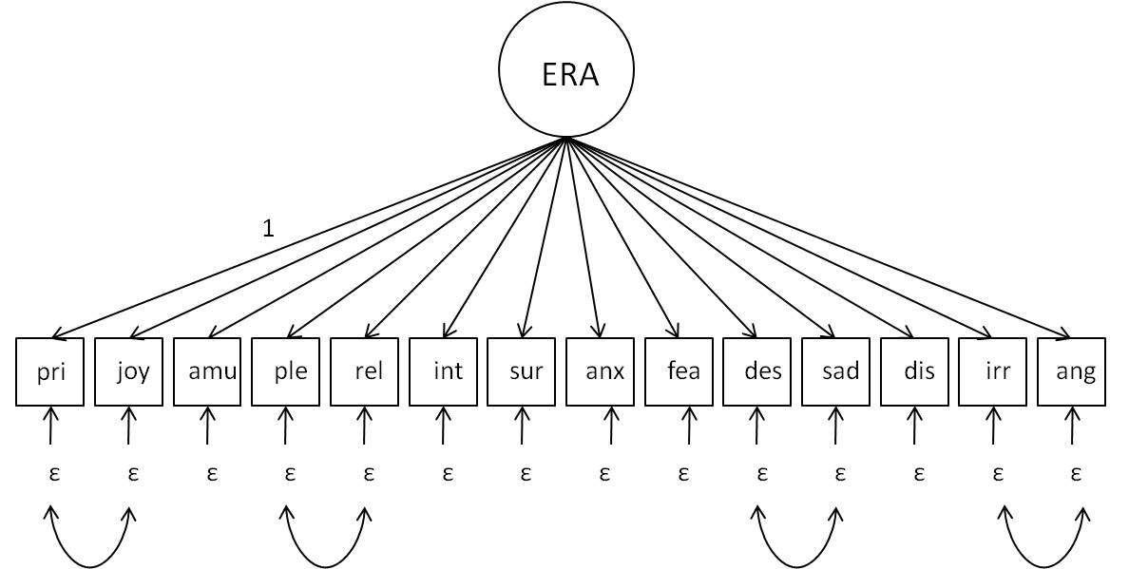
Note. pri=pride, amu=amusement, ple=pleasure, rel=relief, int=interest, sur=surprise, anx=anxiety, fea=fear, des=despair, sad=sadness, dis=disgust, irr=irritation, ang=anger, ERA=emotion recognition ability; model fit: CFI= .910, RMSEA=.058, SRMR=.050. Double-headed arrows represent residual correlations that can be interpreted as minor facets of overall ERA. This model had been reported in Schlegel, Grandjean, & Scherer (2012) and was calculated based on the same sample of N=295 as in the present study.

Figure S2
Age differences in GERT subscale and total GERT scores.

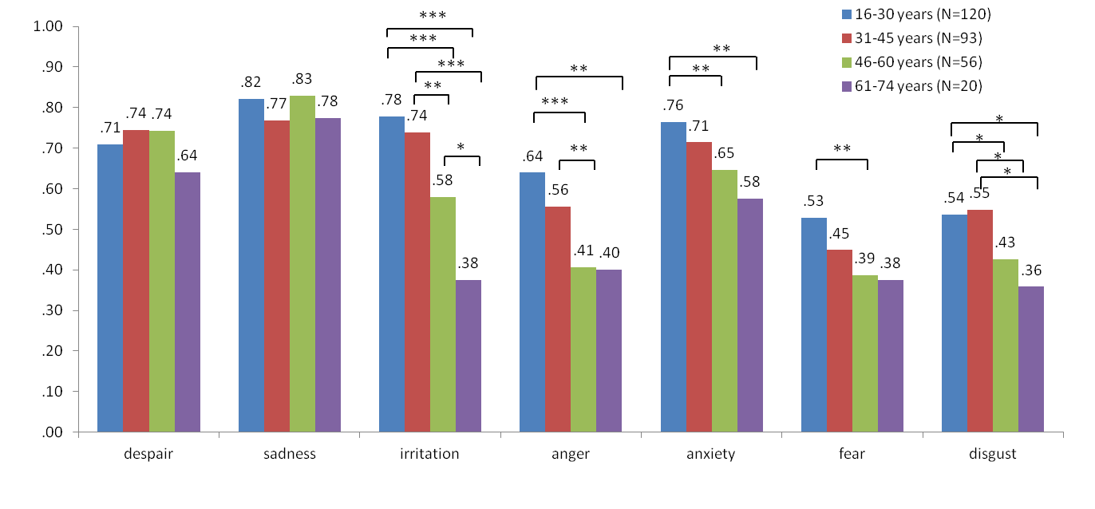

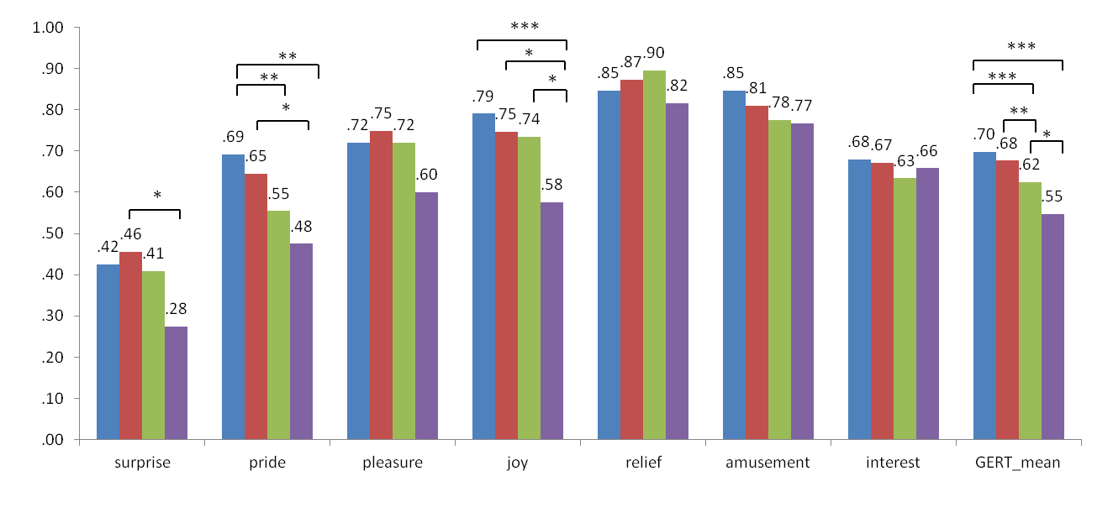
Note. Displayed are percentages correct per subgroup. *<.05, **<.01, ***<.001.

Figure S3
Gender differences in GERT subscale and total GERT scores.
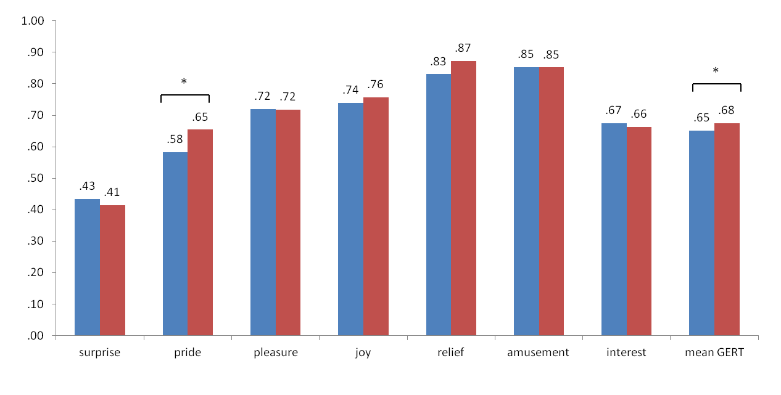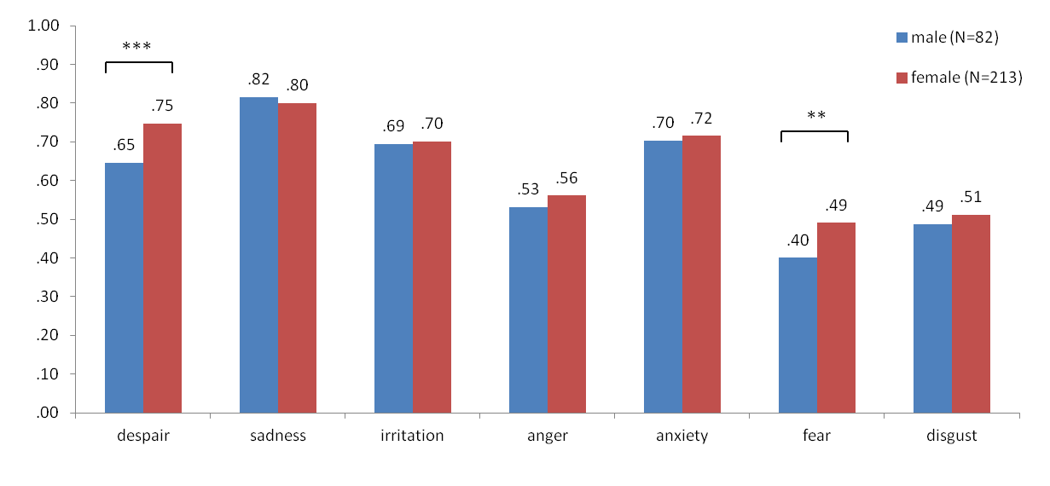
Note. Displayed are percentages correct per subgroup. *<.05, **<.01, ***<.001.

