[Insert catchy title here]
[Author 1¹, Author 2², Author 3^{1, 2}]
1Department of dairy products, Faculty of Medicine, University of Geneva
2Department of Winery, Faculty of Medicine, University of Geneva

1 loaf (1 lb) French bread, cut into 1-inch pieces; 2 cups shredded Swiss cheese (8 oz); 2 cups shredded Gruyère [1] or Swiss cheese (8 oz)*; 2 tablespoons all-purpose flour 1 clove garlic, cut in half; 1 cup dry white wine or nonalcoholic white wine; 1 tablespoon lemon juice; 3 tablespoons kirsch, dry sherry, brandy or nonalcoholic white wine.
In resealable plastic food-storage bag, place cheeses and flour. Shake until cheese is coated with flour. Rub garlic on bottom and side of fondue pot, heavy saucepan or skillet; discard garlic. Add wine. Heat over simmer setting on fondue pot or over low heat just until bubbles rise to surface (do not boil). Stir in lemon juice. Gradually add cheese mixture, about 1/2 cup at a time, stirring constantly with wire whisk over low heat, until melted. Stir in kirsch. Keep warm over simmer setting. If prepared in saucepan or skillet, pour into a fondue pot or heatproof serving bowl and keep warm over low heat. Fondue must be served over heat to maintain its smooth, creamy texture. Spear bread and fruit with fondue forks; dip and swirl in fondue with stirring motion (Figure 1). If fondue becomes too thick, stir in 1/4 to 1/2 cup heated wine [2].

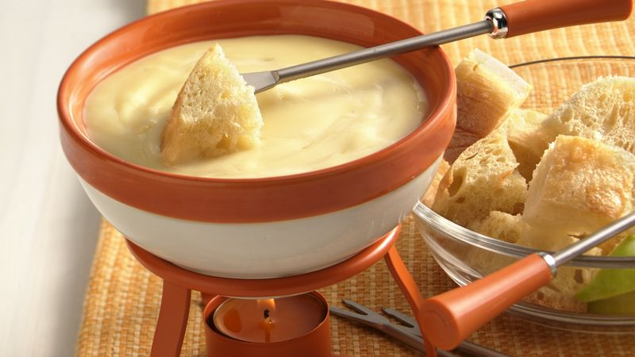
Figure 1: Suggestion for fondue presentation.

[1] Portnoi PA, MacDonald A. Determination of the lactose and galactose content of cheese for use in the galactosaemia diet. J Hum Nutr Diet. 2009 Oct;22(5):400-8. doi: 10.1111/j.1365-277X.2009.00948.x.
[2] https://www.bettycrocker.com/recipes/cheese-fondue/b63e7bd8-6f46-4daf-bcb0-e67a6388a1bb

(NOTES: 1 page with 1500 characters maximum
Please keep the template format and save file as SURNAME.name)

