Swiss-European Mobility Programme (ex-ERASMUS) Student Mobility for Studies
Learning Agreement for Studies – Plan d’études

Academic year: Semester (fall, spring or year): Field of study:

First Name and Last Name of the student:

Sending institution: Université de Genève (University of Geneva) ; CH GENEVE01 ; Country: Switzerland

SENDING INSTITUTION (UNIGE)

We confirm that the proposed plan of study/learning agreement is approved.

Academic coordinator’s signature/Signature de votre conseiller/ère académique/aux études

Full Name ………………………………………………………………………….. Stamp:

Date :

RECEIVING INSTITUTION (Uni d’Accueil)

We confirm that the proposed plan of study/learning agreement is approved.

Academic coordinator’s signature/Signature de votre conseiller/ère académique

Full Name……………………………………………………………………………….. Stamp:

Date :

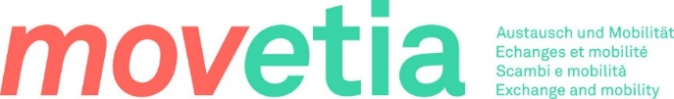

DETAILS OF THE PROPOSED PLAN OF STUDY ABROAD/LEARNING AGREEMENT

Receiving institution : Country :

Courses at the receiving institution |  |  | Courses at the sending institution (UNIGE)
Course unit code | Course unit title (as indicated in the course catalogue) | Number of ECTS | Équivalence | Crédits ECTS UNIGE
Your LA can be modified until 3 weeks after the beginning of your semester at the receiving institution.
It has always to be approved by both parties (receiving University and your Faculty at UNIGE)

DETAILS OF THE PROPOSED PLAN OF STUDY ABROAD/LEARNING AGREEMENT

Receiving institution : Country :

Courses at the receiving institution |  |  | Courses at the sending institution (UNIGE)
Course unit code | Course unit title (as indicated in the course catalogue) | Number of ECTS | Équivalence | Crédits ECTS UNIGE
Your LA can be modified until 3 weeks after the beginning of your semester at the receiving institution.
It has always to be approved by both parties (receiving University and your Faculty at UNIGE)

